

**TUNKU ABDUL RAHMAN UNIVERSITY COLLEGE**

**FACULTY OF COMPUTING AND INFORMATION TECHNOLOGY**

Bachelor of Computer Science (Honours) in Data Science

Year 3

RDS3 G3

**Written Assignment**

BACS3033 Social and Professional Issues

2021/2022 (session 202109)

| **Name**  **(Block Capital)** | **Registration No.** | **Signature** | **Marks**  (For Lecturer / Tutor use) |
| --- | --- | --- | --- |
| 1.ONG T’NSAM | 20WMR08883 | T’nsam |  |
| 2.KOW YEE HUI | 20WMR08868 | *yee* |  |
| 3.KONG MUN JUN | 20WMR08867 | KongMJ |  |

Lecturer/Tutor’s Name: Ms Wong Jee Foong

Date of Submission: 12/2/2021

**Assignment Final Report Assessment Criteria**

The assessment of this final assignment report is based on the following criteria:

**Assessment Criteria**

| **Criteria** | **Excellent** | **Good** | **Average** | **Poor** | **Score** |
| --- | --- | --- | --- | --- | --- |
| **Part A**  **Background**  **(5%)** | Apparent description about the background of the contemporary topic selected.  **(4 - 5%)** | Some part of description about the background of the contemporary topic selected with ambiguity.  **(3%)** | Brief description about the background of the contemporary topic selected, which are not directly related to the question.  **(2%)** | Very brief description about the background of the contemporary topic selected, which are not related to the question.  **(0 - 1%)** |  |
| **Part B**  **Topic analysis and exploration.**  **(30%)** | Able to provide apparent and reasonable assessment & justification with very detailed explanations on the chosen topic from social, legal, architecture and market perspectives. Able to look for relevant  information from many  sources within the duration of time given and well utilize it.  **(24 - 30%)** | Good to provide reasonable assessment & justification on the chosen topic from social, legal, architecture and market perspectives. However, some explanations are not clear. Able to look for relevant information from many sources, but some information is not used wisely.  **(15 - 23%)** | Average to provide reasonable assessment & justification with a bit of explanation on the chosen topic from social, legal, architecture and market perspectives. Able to look for information from many sources, but some of them are irrelevant.  **(8 - 14%)** | Poor to provide reasonable assessment & justification with very little to no explanation on the chosen topic from social, legal, architecture and market perspectives. Able to look for limited information and subject to limited few sources and some information is irrelevant.  **(1 - 7%)** |  |
| **Part C**  **Proposed solution(s) for your chosen topic.**  **(30%)** | Able to provide an apparent and reasonable evaluation with detailed explanations on the proposed solution(s) for your chosen topic. Able to apply the  new ideas and thoughts in solutions and  able to use it for  autonomous learning.  **(24 - 30%)** | Good to provide a reasonable evaluation of the proposed solution(s) for your chosen topic. However, some explanations are not clear. Able to apply new ideas  or thoughts in solutions  in most  situations and able to use  them without assistance.  **(15 - 23%)** | Average to provide a reasonable evaluation with a bit of explanation of your chosen topic's proposed solution(s). Able to apply new ideas  or thoughts in solutions under  certain  situations and can only use  them with some assistance.  **(8 - 14%)** | Poor to provide a reasonable evaluation with very little to no explanation on the proposed solution(s) for your chosen topic. Unable to receive & apply new ideas or thoughts on a solution.  **(1 - 7%)** |  |
| **Summary**  **(10%)** | Able to provide an apparent summary on the topic chosen.  **(8 - 10%)** | Good to provide a summary on the topic chosen.  **(6 - 7%)** | Average to provide summary on the topic chosen.  **(4 - 5%)** | Poor to provide a summary on the topic chosen.  **(1 - 3%)** |  |
| **Sub-Total (75%)** | | | | |  |

| **Criteria** | **Excellent** | **Good** | **Average** | **Poor** | **Score** |
| --- | --- | --- | --- | --- | --- |
| **Part D**  **Ethical evaluation**  **(25%)** | Able to provide an apparent and reasonable assessment of ethical issues raised from the chosen topic. Excellent justification on such ethical issues with well appropriate selection of the ethics philosophy to support it. Able to give excellent interpretations and consider numerous views from related perspectives based on facts, rules, and laws relevant to the ethical problem.  **(21 - 25%)** | Able to provide a clear and reasonable assessment of ethical issues raised from the chosen topic. Reasonable justification on such ethical issues with well appropriate selection of the ethics philosophy to support it. However, some explanations are not clear. Able to verify whether the facts are relevant or not based on facts, rules and laws relevant to the ethical problem.  **(16 - 20%)** | Average to provide a clear and reasonable assessment of ethical issues raised from the chosen topic. Average justification on such ethical issues with a little point to support it. Able to gather facts related to ethics problems but some of it is irrelevant.  **(11 - 15%)** | Poor to provide a clear and reasonable assessment of ethical issues raised from the chosen topic. Insufficient justification on such ethical issues with very limited or no point to support it.  **(1 - 10%)** |  |

**TOTAL MARK: /100**

**Lecturer/Tutor’s Feedbacks/Comments:**





**Faculty of Computing and Information Technology**

**Plagiarism Statement**

Read, complete, and sign this statement to be submitted with the written report.

**I confirm that the submitted work are all our own work and are in our own words.**

**Name (Block Capitals) Registration No. Signature**

**1. …ONG T’NSAM…… ……20WMR08883……. ……T’nsam……**

**2. …KOW YEE HUI…     ……20WMR08868…….     ………yee………**

**3. …KONG MUN JUN… ……20WMR08867…….     ……KongMJ……**

**Tutorial Group : RDS3G3**

**Date : …12/2/2021….**

**Acknowledgement**

We would like to appreciate everyone who helped us directly or indirectly. First of all, we would like to thank our tutor Ms Wong Jee Foong for guiding us on how to accomplish this assignment from the beginning by providing us detailed information about the tasks that need to be done and clearing any of our doubts. Not only that, Ms Wong also explains to us some of the examples for each part of the assignment so that we are able to gain a better understanding about how we should accomplish our assignment. We would also like to thank our lecturer, Dr.Lim Siew Mooi, for clearing any of our doubts including what not to include in our assignment. Last but not least, we also appreciate our classmates for giving different views during the discussion for the assignment which enables us to be clear about how to proceed our assignment throughout the whole assignment completion process.

**Table of contents**

**Privacy and personal data usage in social media** **1**

**1.0 Background** **1**

2.0 Topic Analysis 3

2.1 Law Perspective 3

2.2 Social Norms Perspective 4

2.3 Market Perspective 5

2.4 Architecture Perspective 6

**3.0 Solutions** **7**

3.1 Law Perspective 7

3.2 Social Norms Perspective 7

3.4 Architecture Perspective 8

4.0 Ethical Evaluation 9

4.1 Kantianism 9

4.2 Ethical Egoism 9

4.3 Act Utilitarianism 10

4.4 Rule Utilitarianism 10

4.5 Social Contract Theory 11

**5.0 Summary** **12**

6.0 References 13

# 

# **Privacy and personal data usage in social media**

## **1.0 Background**

With the feature of Web 2.0, users are able to interact with almost every person to express their personal views and thoughts with the virtualized communities by creating and exchanging opinions and information (Gratzalis, 2014). The medium for this particular interaction to appear in the digital world is known as Social Media (Kaplan, 2010). In this digital era, users are able to define their personal identity by revealing a few aspects of their personalities in social media, namely WhatsApp, Facebook and others. The privacy and personal information obtained from social media may be used by third parties in order to provide meaningful insights such as pop-out advertisements based on the users’ browsing behavior.

However, the users normally do not have concerns about it and this may cause the users’ privacy to be violated. 64% of Malaysians have the thoughts of wondering if their personal data would be leaked on the Internet and social media (Hirschmann, 2021). Also, Facebook is involved in a data breach activity caused by hackers in which 30 million Facebook Users became the victims when their personal data such as phone numbers and email addresses were exposed (Rodriguez, 2018). There are 178 cases of data breach happening locally in 2019 which is a 200% jump of increment compared to 63 attacks in the year 2018 (Yunus, 2019). Due to the rise of technology, data protection has become the priority when improving the networking.

The stakeholders involved in the privacy and personal data usage in social media are **people that are using social media and sharing their personal data in the social media**. These people may not be concerned about the privacy and usage of their personal data in social media such as WhatsApp and Facebook. Also, **social media site (Meta company)** is one of the stakeholders as it is collecting their users’ personal data and using the data for other purposes such as analysing the users’ preferences to customize advertisements and posts related to their preferences. Moreover, stakeholders including **those who are using social media platforms for business purposes**. For instance, they use Facebook’s advertising features to promote their business and use WhatsApp (WhatsApp Business) to chat with their customers. Additionally, one of the stakeholders include **data protection authorities** who will investigate the parties who misuse the users’ personal data for illegal purposes and protect the privacy and personal data of the users.

As exemplification for data protection authorities, Malaysia had established an agency, Personal Data Protection Commissioner (PDPC) under the Ministry Communication and Multimedia Commission (MCMC) (malaysia.gov, n.d.). PDPC Malaysia will oversee how the parties concerned process the personal data of individuals involved in commercial transactions in order to ensure that the personal data of individuals is not misused and misapplied by the parties concerned. In 2010, PDPC Malaysia had proposed the Personal Data Protection Act 2010 (PDPA) which is focused on the processing of personal data in regards to commercial transactions to regulate the networking world (malaysia.gov, n.d.). However, PDPA requires updates and improvements to Malaysia’s data privacy as the technology advances because PDPA awareness is still low among Malaysians while the execution is not as strict as the European Union General Data Protection Regulation (GDPR) (Yunus, 2019).

Additionally, one of the indirect stakeholders is Comparitech which is a UK-based Tech Research company and experienced with test and review products including VPNs, password managers, ID theft protection, antivirus and others (Comparitech, n.d.). Thus, they can easily affect one country economically in terms of technological aspects as the results generated by them are very detailed and complete with trustworthy information. For instance, those findings from Comparitech can be a reference for overseas stakeholders to make decisions in investing their business into certain countries. For example, They have ranked Malaysia along with 47 other countries for privacy protection issues. Malaysia was ranked the fifth-worst country in terms of data protection with a score of 2.6 out of 5, followed by Thailand (2.6) and so on (Comparitech, n.d.). Therefore, legal acts are needed to avoid these theft activities.

## 

## **2.0 Topic Analysis**

Facebook Inc. which is currently known as the Meta Platform Inc, bought Instagram and WhatsApp with 1 billion USD in 2012 (Ians, 2020) and 16 billion USD in 2014 respectively (Woodard, 2020). The aim of the Meta platform is to perform a vertical integration in the social media industry by acquiring and integrating all of four of them, Facebook, Messenger, Instagram and WhatsApp, into one platform (Byers, 2019). However, the U.S. Government tried to stop Facebook from the integration as it will need to face a lot of strict scrutiny to be approved from the antitrust investigation from the Federal Trade Commision (Byers, 2019). This issue was overed due to the lack of evidence from violation of antitrust law.

In the updated privacy policy, WhatsApp mentioned they will collect information automatically such as usage and log information from user WhatsApp activity status, device and connection information from IP address and device operations information, location information with the users’ permission when the users choose to use location-related features, and cookies to customize their services to the consumers (WhatsApp, 2021). Furthermore, WhatsApp also collects information from third parties especially with business accounts on WhatsApp and third-party service providers.

Also, WhatsApp clearly mentioned that when the user messages a business on WhatsApp, the content that the user shares may be visible to several people in the business. This is because the business may give third-party service providers such as Facebook access to the communication to send, store, read, manage and other processes for their business (WhatsApp, 2021). For instance, WhatsApp will share this information with Meta company which include transaction data when involved with Facebook Pay or Shops in WhatsApp, information of interaction with business and service-related information, mobile device information and IP address.

Lily (2021c) indicates that WhatsApp gives their users time to review the new privacy policy and WhatsApp will remind those users who have not accepted the new privacy policy to accept the new privacy policy persistently. If the users did not accept the new privacy policy on 15th May 2021 after persistent reminders, then they are not able to use the full functionality as WhatsApp will deprive users of features gradually (Ankita, 2021). Moreover, the new privacy policy did not provide options for the users to opt-out of this new data sharing policy (Scott, 2021). However, accepting the privacy will not impact the users’ interactions with WhatsApp as all the communication still be end-to-end encrypted which means only the users and people that the users are chatting with can view the chat content.

### **2.1 Law Perspective**

The companies located outside of Malaysia will not be restricted by Malaysia PDPA (PDP, 2010). This means that the **privacy policy implemented by WhatsApp is legal in Malaysia**. If the users give WhatsApp permissions, the Malaysian government will not have the right to take any restrictive measures against Facebook. Also, the Department of Personal Data Protection Malaysia (JPDP) has stated that they will not restrict the usage and privacy policy of WhatsApp in Malaysia (Selan, 2021). However, the **privacy policy of WhatsApp is suspected of misleading users** because WhatsApp has clearly stated that it will not view and collect the user's location information. So, most of the users also believe that they can protect their location information by restricting WhatsApp permission to view the user's address (WhatsApp Help Center, 2021c). In fact, WhatsApp is able to infer the user’s country and region by automatically collecting the user's personal information such as IP address and time zone (WhatsApp, 2021b).

Besides, when users use the third-party products that have partnered with Facebook, the **information of users is shared from third-party products to Facebook**. For instance, the IP address of users will be shared with Facebook when the users share a video from Youtube to WhatsApp. Therefore, Facebook will be able to use the information gathered from third-party products to analyze the types of products that users prefer. This has **violated the user’s right to privacy and is different from the basic data that the public recognizes is being collected**. Besides, the privacy policy of WhatsApp is mandatory as it has **deprived the user’s rights to opt-out**. If the users refuse to agree to the privacy policy, WhatsApp will gradually deprive users of features (Ankita Chakravati, 2021b). WhatsApp also uses **regular notifications to force and threaten users to accept their policy** (Press Trust Of India, 2021).

Furthermore, the privacy policy of WhatsApp has the problem that **users from different countries are treated differently**. The **users in Europe have the right to choose to opt-out**. This is because GDPR enacted by the European Union has the right to protect WhatsApp users in the European Union to reject the new privacy policy (WhatsApp (EEA), 2021). However, **users outside Europe do not have the right to opt-out of the new privacy policy** (Yasmin Ahmed, 2021). The unfair treatment of WhatsApp on implementing the privacy policy has caused dissatisfaction to the users in many countries. GDPR Summary (2021) indicates that all users should have their consent about how the organization uses their personal data. In our opinion, WhatsApp **should implement the same privacy policy for all WhatsApp users**.

### **2.2 Social Norms Perspective**

According to WhatsApp’s privacy policy, **WhatsApp will share information with Meta Companies** such as sharing the transaction data with Meta Companies if the users use Facebook Pay or Shops in WhatsApp (WhatsApp Help Center, 2021b). Additionally, when the user messages a business on WhatsApp, **the content that the user shares may be visible to several people in the business** as some of the business may give third-party providers access to its communications for business purposes. The data from business conversations will also be shared with Facebook (Deeksha, 2021) for commercial purposes such as advertisement targeting (Campbell, 2021a). As a result, **some of the WhatsApp users do not accept the new privacy policy** because they **do not want their data to be shared with Facebook** as there is **no privacy** for them.

Moreover, the **users will not have full functionality of WhatsApp** such as not being able to read or send messages **until they accept the new privacy policy** (Doffman, 2021). Although WhatsApp mentioned that they will not delete the accounts even though the users did not accept the new privacy policy, but **this has forced the WhatsApp users to accept the new privacy policy** because if they did not accept the new privacy policy on 15th May 2021 after persistent reminders, then they are not able to use the full functionality as WhatsApp will deprive users of features gradually (Ankita Chakravati, 2021a). **This may impact the WhatsApp users negatively** because they will **face the problem of sending and receiving messages from others**. Consequently, this will raise the dissatisfaction of WhatsApp users as they are forced to accept the new policy. This may cause the users to use another messaging app to communicate with others.

However, **some of them agree to the new privacy policy** as the **new privacy policy allows the businesses to use Facebook to reply to their customers’ enquiries** (Martin, 2021). This will be **beneficial to those businesses** as it provides a more convenient way for them to manage their customer’s enquiries and they can reply to their customers in a shorter period of time. Moreover, when the users communicate with the business, the **conversation and information will be used by Facebook for marketing purposes** which may include advertising on Facebook (WhatsApp Help Center, 2021a). Indirectly, this can **increase Facebook’s competitive advantages and advertising revenue**. This is because Facebook has advanced advertising features which will pop out the advertisements related to the customers’ preferences and help the businesses have a higher chance to sell out more products. So, this will attract more businesses to advertise on Facebook in order to boost their revenue.

In order to ensure that the users are informed, **WhatsApp will label the conversations with businesses so that the users know that they are chatting with the businesses** that are choosing to use the hosting services from Facebook. Additionally, **after accepting the new privacy policy, there is no impact on the interactions with WhatsApp**. This is because **all the communications on WhatsApp are still end-to-end encrypted** which means that all the conversations will only be able to be viewed by the users themselves and the person who they are chatting with (Lily, 2021a). Therefore, this is subject to the user’s own opinion whether to accept or decline the new privacy policy updated by WhatsApp as both have its own advantages and disadvantages.

### **2.3 Market Perspective**

The acquisition of WhatsApp in 2014 is a key step for Facebook to gain significant market share in the social media segment. Facebook will use the data collected by WhatsApp in the operation, improvement, provision and marketing of products and services. Referring to Appendix 4, Facebook’s advertising revenue has increased from 2020 to Q3 2021, (Facebook, 2021a). It indicated that **the accuracy of Facebook’s advertising has attracted more and more businesses to join**. According to the new privacy policy, Facebook is able to use more of the shared data to more specifically serve user preferences. As a result, the **Meta company has gained more competitive advantages** over other social media platforms in attracting businesses to invest in their advertising.

**WhatsApp users will prefer to use WhatsApp’s competitor’s products due to their dissatisfaction with the user’s privacy policy**. According to Appendix 5, it shows that there is no significant difference between the number of WhatsApp users in 2020 and the number of WhatsApp users in 2021 (Brian, 2021a). It indicates that many users are dissatisfied with the user privacy policy updated in 2021. Some of the users will be more preferred to other social media platforms with better privacy policies. Based on Appendix 6, it shows that the number of WeChat users is gradually increasing from 2020 to 2021 (Thomala, 2021). Although WhatsApp’s shared data can let them be more aware of users’ preferences, they have also **lost their competitive advantage in attracting new users**. Additionally, after the announcement of changing privacy policy made by WhatsApp, the number of users of Telegram messaging apps increased after mere days (Lily, 2021b). This means most WhatsApp users are concerned with their privacy, so they prefer to use other apps which offer better privacy protection.

Moreover, **the way Facebook commercializes shared data will effectively monopolize the social media market**. Facebook’s precise advertising has caused other social media platforms and advertisers to lose the ability to compete with them. As a market monopolist, **Facebook companies will be able to increase the prices of their products and services at will**. In order to achieve the effect of market monopoly, Facebook may even formulate more demands and violations of the user privacy policy. However, the market monopoly is not favorable to Facebook. **Facebook will need more costs such as labor costs to support its increasing product output**.

### **2.4 Architecture Perspective**

According to WhatsApp, the updated privacy policy mentioned that **both WhatsApp and Facebook are not able to view the users’ personal messages or hear their calls** as **end-to-end encryption** is used. The end-to-end encryption technique WhatsApp used is **Signal Protocol developed by Open Whisper Systems** (Business Today, 2019) as shown in Appendix 7. By having the end-to-end encryption, the users’ messages are secured with a lock, only users and the recipient have the special key to unlock and read the messages (WhatsApp Help Center, 2021b). Therefore, the **end-to-end encryption used by WhatsApp is able to secure their users’ messages, photos, videos, voice messages, documents, status updates and calls being viewed by third parties** which also include WhatsApp (Quint, 2020).

However, the **messages between users and the businesses are not end-to-end encrypted and will be visible to several people in the business**. This is because the data in the business messages can be used by Facebook for commercial purposes such as advertisement targeting (Campbell, 2021b). Additionally, the **end-to-end encryption is not applicable to the chat backup files that are saved in a folder on the devices or cloud**. For instance, the backup files of the chat can be exported to third party services such as Google Drive for backup purposes. Also, **screenshots of the chats** that are saved by the users in their gallery are not encrypted and the screenshots may be stolen by others when the users’ phone is hacked by others. This indicates that the users’ personal messages are possible to be accessed by unauthorized users and the **data encryption of WhatsApp is not totally secure** as the **encryption is not applicable to other platforms which are outside of the encrypted WhatsApp platform** (Quint, 2020).

Also, **WhatsApp's privacy policy is categorized as opt-out policy** which means that WhatsApp can share the users’ information with Facebook until the users explicitly forbid it. **Previously, users were allowed to opt-out of sharing their personal data** with Facebook’s advertisement tracking service. However, the **new privacy policy did not provide options for the users to opt-out of this new data sharing policy** (Scott, 2021). This indicates that the users have no option to choose not to share their personal data such as phone numbers, transaction data, service-related information and so on with Facebook. **In our opinion, this is not acceptable** because users should have the right to choose whether or not to share their personal data with Facebook.

## **3.0 Solutions**

### **3.1 Law Perspective**

From a legal perspective, **Malaysia PDPA 2010 should be strengthened such that its legal scope should include control of the data usage rights of overseas companies stationed in Malaysia**. Also, the **PDPC Malaysia should monitor the use of data to prevent the personal data of Malaysians from being misused**. For instance, it should take measures and penalties against social media platforms that abuse users’ personal data without authorization such as it should also prohibit WhatsApp from using users’ data without authorization.

Besides, Malaysia Competition Commission (MYCC) has carried out numerous investigations and audits, some of which are of considerable importance and should be of interest. For instance, the **Competition Act 2010** under MYCC contains provisions prohibiting anti-economic agreements that significantly restrict, prevent or distort the objective and effects of the market competition (Amalina & Hanizah, 2021). This decree **should be adopted by WhatsApp to prevent them from harming Malaysia’s social media market at will and commercializing users’ data**. Greig (2021) indicates that **WhatsApp was slapped with 225 million** euros after GDPR research performed by the Data Privacy Commissioner (DPC) observed that the WhatsApp platform became no longer obvious about the way it shared information with its discern Meta Company. In our opinion, we think that **Malaysia data protection authorities should also take the same measures as DPC to charge WhatsApp if WhatsApp did not follow the data protection laws enforced**.

### **3.2 Social Norms Perspective**

From social norms perspective, the solution for the WhatsApp new privacy policy is **relevant authorities should put pressure towards WhatsApp and Facebook** in order to make sure that the updated privacy policy follows certain rules which protect the users’ privacy such as continuing to honor the privacy promises made to the users before acquisition (Law, 2021). This is evidently seen when the Federal Trade Commission’s (FTC) Bureau of Consumer Protection had sent a letter to Facebook and WhatsApp for their obligation to protect their users’ privacy due to Facebook’s proposed acquisition of WhatsApp in 2014 (Law, 2021).

Additionally, **WhatsApp should highlight the part of the privacy policy that is updated and state clearly how this new privacy policy affects the users** so that the users can gain a better understanding about the changes of the updated privacy policy and **prevent confusion** about how WhatsApp is implementing the updated privacy policy. Moreover, **WhatsApp can perform an online survey** to collect the users’ opinion before they update their privacy policy. Therefore, WhatsApp can **take into consideration their users’ feedback when updating their privacy policy**.

**3.3 Market Perspective**

Firstly, the market’s distrust of WhatsApp’s user privacy policy is the most necessary to be addressed. There should be **changes in the way that WhatsApp and Facebook share data for business purposes**. For instance, the update for the privacy policy of WhatsApp should be based on the opinions of users. This is because when WhatsApp no longer becomes the user’s first choice due to privacy reasons, the competitive ability of WhatsApp will be decreased. Also, due to the privacy issues, WhatsApp has already caused many users to be dissatisfied. This is highlighted when WhatsApp indirectly forces their users to accept the new privacy policy by constantly popping out notifications to urge users to agree to their new privacy policy. In order to improve the users’ satisfaction, **WhatsApp should respect users’ right to choose whether or not to accept the latest privacy policy**, namely restoring the opt-out function is the best option for WhatsApp.

Besides, the **government and other social media platforms should cooperate with each other to resist Facebook’s market monopoly**. Facebook’s malicious market monopoly behaviors such as the forced acquisition of small social media platforms. For instance, the acquisition of Instagram with only 13 employees in 2012 (Mark, 2020). This indicates that Meta company maliciously suppresses and acquires all companies that could become their competitors. In order to avoid the monopolistic behavior of the Meta company leading to more and more social media platforms being unable to survive in the market, the **government should cultivate more competitors that can compete with Facebook**. For example, the **government should appropriately give other social media platforms opportunities and subsidize their development**. Briefly, the social media market and government should work together to maintain healthy competition between the markets so that the users can benefit from it.

### **3.4 Architecture Perspective**

From an architecture perspective, there is **a problem with the data encryption of WhatsApp** because the **data encryption is not totally secure** as some of the users might take a screenshot of the chat and send it to others. In order to solve the problem of data encryption, **WhatsApp should include a new term in their privacy policy which is when the user screenshot the chat, WhatsApp will notify the sender of the message**. By doing so, the person who is chatting with the user will be notified that the user screenshot the chat and hence **this can protect the privacy of the sender of the message**. There are other social media which implement this screenshot notification policy in order to protect their users’ privacy.

Also, Instagram will notify the sender of the message when the user screenshot the disappearing photo or video sent to the user through direct message (John, 2021). Furthermore, Snapchat will also send a message “You took a screenshot!” to the person who you are chatting with when you take a screenshot of the chat (John, 2019). Moreover, **regarding the opt-out policy, WhatsApp should allow the user to choose whether or not to opt-out of sharing their personal data with Facebook** by restoring the opt-out function is the best option for WhatsApp. This is because the **user should have the right to choose who can access their personal data**.

## **4.0 Ethical Evaluation**

### **4.1 Kantianism**

Kantianism **focuses on the intentions of the actor and emphasizes humanity**. According to **Kantianism's first formulation**, the **action must be acted only from moral rules proposed that can be followed by everyone and there is no contradiction or problems with the rules**. Then, everyone will perform the action according to the proposed rules. In this case, **when WhatsApp implemented the new privacy and policy, WhatsApp thought and acted from the moral laws before accessing and collecting the consumers’ personal data**. This is because WhatsApp will **acknowledge the users by labelling the conversations with businesses so that the users know that they are chatting with the businesses** and their personal data might be exposed to the parties involved in the businesses. Also, **they will protect the users’ privacy such that all the communications on WhatsApp are still end-to-end encrypted** which means that all the conversations will only be able to be viewed by the users themselves and the person who they are chatting with (Lily, 2021). Therefore, the action taken by WhatsApp is ethical.

However, **WhatsApp did not implement the second formulation of Kantianism theory**. According to the second formulation of Kantianism, good will is proposing actions that will be the best for both yourself and other people and never only as a means to an end. It is unethical if using someone to get an end. For instance, **WhatsApp is unethical when they implement the latest privacy policy which is aimed to collect more privacy data from the users to gain benefits for themselves in the aspect of business**. This is because they access users' personal data to have a greater advantage than their competitors but they **did not consider the privacy of their users which brings harm to the users** which is users do not have their own privacy. Also, **they are more concerned with the profits and have neglected the possible negative impacts that will affect their users**.

### **4.2 Ethical Egoism**

According to the theory of ethical egoism, it is a normative theory and the action is ethical as long as **it can promote its interest and anything that is not promoted is unethical** (Alexander, 2021). In this case, **WhatsApp implemented the new privacy policy because they believe that the privacy policy allows them to gain a lot of benefits**. Also, they believe that this action is ethical even if it does not respect the privacy of the users because **Meta company is able to obtain more benefits when they are able to access more users’ personal data through the latest privacy policy**. Furthermore, users’ data sharing can help Facebook to gain a greater competitive advantage than other social media platforms. This is evidently seen when the shared data can help Facebook (Facebook businesses) and businesses that collaborate with Facebook obtain more useful information such as user’s interests, preferences and living habits for marketing purposes.

Therefore, most of the cooperative partners supported the updated privacy policy of WhatsApp because sharing data was able to increase their revenue. **The superior competitive advantage also brings long-term benefits to Facebook**. This is because the businesses that use Facebook and WhatsApp for business purposes will continue to associate with the Meta company due to the advanced advertising features and marketing platform provided by Facebook which allows them to have a higher chance to sell out their products. Briefly, it can be seen that the updated privacy policy has brought a number of short-term and long-term benefits to the Meta company. So, **the action of proposing the new privacy policy by WhatsApp is considered as ethical action.**

### **4.3 Act Utilitarianism**

According to the act utilitarianism theory, the **action is right to the extent that it increases the affected parties’ total happiness** such that the action which benefits utilitarians a lot is ethical. In this case, the **right action for a utilitarian is to agree to the new privacy policy announced by WhatsApp which can bring a lot of benefits to the affected parties** such as social media sites (Meta company), people who are doing business in Facebook and WhatsApp users. This is evidently seen when **Facebook can gain more competitive advantages and earn higher advertising revenue** when WhatsApp shares the data from business conversations with Facebook for commercial purposes such as advertisement targeting (Deeksha, 2021). By collecting the information on how users interact with businesses when using WhatsApp, the advertisement features provided by Facebook will be based on users’ preferences and allows the businesses to have a higher chance to sell out more products. Therefore, more businesses started to advertise their products on Facebook. This is highlighted when the advertising revenue has increased by 33% from 2020 to Q3 2021 after the implementation of new privacy policy (Facebook, 2021b).

Additionally, **Facebook pop out advertisements based on users’ preferences allowing the users to view more customized advertisements**. This may increase users’ satisfaction as it is more convenient for the users to find the products that they are interested in. Also, those **people who are doing their business on Facebook can be more responsive to their customers**. For instance, businesses can manage their customers’ enquiries and reply to their customers through WhatsApp (WhatsApp Business) in a shorter period of time (Martin, 2021). So, **the action of agreeing to the updated privacy policy of WhatsApp can bring greatest happiness over unhappiness to Meta company, people who are using social media and those businesses**. Briefly, **a utilitarian may think that this action is good as it brings a lot of benefits to the affected parties**. Although agreeing to the updated privacy policy of Whatsapp will bring some negative impacts to the affected parties such as the social media users do not have their own privacy and some of the users might use other messaging apps instead of WhatsApp, but this would not be the main concern to a utilitarian. This is because the benefits of agreeing to the new WhatsApp’s privacy policy outweigh the harms it brings to the affected parties.

### **4.4 Rule Utilitarianism**

The principle of utility in rule utilitarianism refers to the **rules that can** **benefit the majority of people**. In rule utilitarianism, the rule is good when it can most usefully generate happiness with the greatest utility. In some cases, it may also bring some loss to people although it can bring a greater benefit to most people. In this case, WhatsApp proposed a privacy policy for WhatsApp which was launched in 2021. The **proposed rule** is that **accepting the new privacy policy proposed by WhatsApp is able to benefit the affected parties**. This rule is **beneficial for the Meta company and the businesses that use Facebook and WhatsApp for commercial purposes**. The main benefit that Facebook has received is its ability to use the advantages of **data sharing technology to attract more businesses to choose their advertising business plans.** This indicates that the new privacy policy helps Facebook to gain a greater competitive advantage than other social media platforms. By following this rule, merchants who use Facebook and WhatsApp for commercial purposes and the businesses that have purchased Facebook advertising packages also gained benefits. This is because the **businesses can analyze their future development plans more effectively and improve their products** based on data analysis results obtained. Besides, the advertising targeted at user needs and interests can also **increase the businesses’ sales**. In general, the beneficiaries of this proposed rule are Facebook and the businesses that cooperate with it.

However, this rule is **harmful to WhatsApp users**. When the users are forced to abide by this rule, their **privacy rights have already been violated**. This is because in the new privacy policy, chat information between users and businesses is not protected by end-to-end encryption and the users’ data will also be shared on the Facebook platform (Carlos Campbell, 2021c). Therefore, the privacy and rights of the users are actually violated as their **data is not protected** and used for **commercial purposes**. Briefly, although compliance with this rule will bring benefits to certain groups of people such as Facebook companies and businesses that use Facebook and WhatsApp for business purposes, it harms the privacy of WhatsApp users. Due to the proportion of the number of victims and the beneficiary group, the **harm of complying with this rule outweighs the benefits**. This is because with the gradual development of social media, the number of WhatsApp users has reached 2 billion in 2021 (Brian, 2021b) but there are only 78 companies under Facebook (Carly, 2021). Besides, the businesses that advertise their products and services on the Facebook platform are also a smaller proportion than the user group, it only has as much as 200 million small businesses that use Facebook for commercial purposes (Maryan, 2021). Therefore, we can conclude that **this rule is unethical**.

### **4.5 Social Contract Theory**

According to social contract theory, the **action is right if we follow the rules and regulations of law enforced by the relevant authorities**. The **PDPC has the legal right to enforce laws to protect the usage of personal data by third parties**. It has **implemented and executed PDPA 2010** laws in order to **protect individuals’ personal data in business transactions and e-commerce** (Healey, n.d.). In this case, based on the social contract theory, **WhatsApp has to implicitly agree to this social contract** when updating their privacy policy to ensure that their users’ personal data is being protected when the users are interacting with businesses through WhatsApp. This is because **everyone is concerned about privacy issues** such as how their personal data is being used by the social media site. Also, if WhatsApp did not follow the PDPA 2010 laws, then PDPC has the right to do investigation and stop the data user from processing the data if required (Healey, n.d.). Therefore, **the action of WhatsApp updating its privacy policy will be considered as ethical if it follows the laws enforced by PDPC** as it is important that the data users protect their users’ personal data from unauthorised parties in order to prevent data breach from happening.

## **5.0 Summary**

In a nutshell, communities are trending with social media applications such as WhatsApp, Facebook and Instagram but the majority were concerned that their privacy and personal data might be violated by some platforms. Moreover, in terms of privacy issues, Malaysia has ranked the fifth-worst country after being reviewed by Comparitech Company. Although the data were being protected by the PDPC, the Personal Data Protection Act 2010 implemented in Malaysia is far outdated to protect the privacy of citizens in the virtual community. There are five stakeholders who are involved in the privacy and personal data usage in social media have been identified which include the social media site (Meta company), social media users, businesses that use social media platforms for business purposes, data protection authorities, academic and technical community. In the scenario of privacy and personal data usage in social media, we explore the issues on the updated privacy policy of WhatsApp.

This issue was analyzed from the aspect of social, legal, architecture and market. From a **law** perspective, **how to regulate the law to the updated privacy policy of WhatsApp was investigated**. For instance, the privacy policy of WhatsApp is suspected of misleading users because WhatsApp has clearly stated in the privacy policy FAQ that it will not view and collect the user's location information but the reality is that WhatsApp is able to infer the user’s country and region by automatically collecting the user's personal information. On the other hand, from the **perspective of the social norm**, **how society reacts to the updated privacy policy such that they agree or disagree with the new privacy policy was analyzed**. For example, the reasons for WhatsApp users agreeing or disagreeing with the new privacy policy are being analyzed.

Additionally, from a **market** perspective, **the economic realities of the new privacy policy proposed by WhatsApp were analyzed**. For example, Facebook commercializing shared data will effectively monopolize the social media market because the accuracy of Facebook’s advertising has attracted more and more businesses to join. Moreover, from an architecture perspective, the encryption technology implemented by WhatsApp was analyzed. For instance, the secure level of the end-to-end encryption technique used by WhatsApp was analyzed.

In addition, several solutions were also suggested through the perspective of social, legal, architecture and market. The ethical evaluation was performed on the action performed by the stakeholders. After ethical evaluation with various ethics principles which include Kantianism, ethical egoism, act utilitarianism, rule utilitarianism and social contract theory, it can be concluded that the action of WhatsApp implementing the new privacy policy in terms of data protection can be ethical or unethical which depends on different philosophy ethic viewpoint.

(5992 words)

## 

## **6.0 References**

Amalina & Hanizah 2021, ‘Recent Competition Law Cases In Malaysia - Anti-trust/Competition Law - Malaysia’， *Mondaq.com.*，viewed 27 November 2021, <<https://www.mondaq.com/antitrust-eu-competition-/1098642/recent-competition-law-cases-in-malaysia>>.

Amichai-Hamburger 2010, “Social Network Use and Personality”, viewed 10 November 2021, <<https://www.researchgate.net/publication/220496030_Social_Network_Use_and_Personality>>.

Ankita Chakravati 2021, ‘WhatsApp new privacy policy: These features won’t work after May 15 if you don’t accept it’, viewed 27 November 2021, <<https://www.indiatoday.in/technology/news/story/whatsapp-new-privacy-policy-these-features-won-t-work-after-may-15-if-you-don-t-accept-it-1801269-2021-05-11>>.

Alexander, M 2021, ‘Egoism | Internet Encyclopedia of Philosophy’, Iep.utm.edu., <<https://iep.utm.edu/egoism/>>.

Brian, D 2021, ‘WhatsApp 2021 User Statistics: How Many People Use WhatsApp?’, viewed 27 November 2021, <<https://backlinko.com/whatsapp-users>>.

Business Today 2021, How does WhatsApp end-to-end encryption work, viewed 27 November 2021, <<https://www.businesstoday.in/latest/story/how-does-whatsapp-end-to-end-encryption-work-156881-2019-01-08>>.

Byers 2019, “Facebook wants to integrate Instagram and WhatsApp. The U.S. government may try to stop it”, viewed 25 November 2021, <https://www.nbcnews.com/tech/tech-news/facebook-wants-integrate-instagram-whatsapp-u-s-government-may-try-n1101146>.

Carlos Campbell 2021, WhatsApp is having another go at explaining its privacy policy to users, viewed 27 November 2021, <<https://www.theverge.com/2021/2/18/22289595/whatsapp-privacy-policy-app-banner-explanation-telegram>>.

Carly, H 2021, ‘Everything Facebook Owns: Mergers and Acquisitions from the Past 15 Years’, *TitleMax*, viewed 27 November 2021, <<https://www.titlemax.com/discovery-center/lifestyle/everything-facebook-owns-mergers-and-acquisitions-from-the-past-15-years/>>.

Comparitech n.d., “Comparitech - Tech researched, compared and rated”, viewed 10 November 2021, <<https://www.comparitech.com/>>.

Comparitech, 2018, ‘Surveillance States: Which countries best protect privacy of their citizens?’, viewed 10 November 2021, <https://www.comparitech.com/blog/vpn-privacy/surveillance-states/>.

Deeksha 2021, WhatsApp Privacy Policy 2021: What happens if I don’t accept WhatsApp new terms?, viewed 27 November 2021, <<https://www.gadgetsnow.com/faqs/what-will-happen-if-i-do-not-accept-whatsapp-new-privacy-policy/articleshow/81308329.cms>>.

Doffman 2021, Why You Should Quit WhatsApp As Critical New Update Confirmed, viewed 27 November 2021, <<https://www.forbes.com/sites/zakdoffman/2021/03/06/stop-using-whatsapp-after-facebook-apple-imessage-signal-and-telegram-privacy-backlash/?sh=62ccc71b33e8>>.

Facebook 2021, ‘Facebook Reports Third Quarter 2021 Results’, viewed 1 December 2021, <<https://investor.fb.com/investor-news/press-release-details/2021/Facebook-Reports-Third-Quarter-2021-Results/default.aspx>>.

GDPR Summary 2021, ‘GDPR Summary’, viewed 21 November 2021, <<https://www.gdprsummary.com/gdpr-summary/>>.

Greig, J 2021, ‘WhatsApp fined $267 million for GDPR violations | ZDNet’, *ZDNet.com*, viewed 24 November 2021, <<https://www.zdnet.com/article/whatsapp-fined-267-million-for-gdpr-violations-in-ireland/>>.

Gritzalis 2014, “History of Information: The case of Privacy and Security in Social Media”, viewed 10 November 2021, <<https://www.infosec.aueb.gr/Publications/INFOHIST-2014%20Legal%20Publications.pdf>>.

Hirschmann 2021, “Malaysia: likelihood of personal data leak 2019”, viewed 10 November 2021, <<https://www.statista.com/statistics/1040861/malaysia-likelihood-breach-personal-data/>>.

Isaac, M 2019, “Zuckerberg Plans to Integrate WhatsApp, Instagram and Facebook Messenger”, viewed 25 November 2021, <https://www.nytimes.com/2019/01/25/technology/facebook-instagram-whatsapp-messenger.html>.

indianexpress.com 2021, “Facebook could be working on integrating Messenger with WhatsApp”, viewed 25 November 2021, <https://indianexpress.com/article/technology/social/facebook-is-working-on-integrating-messenger-with-whatsapp-7279915/>.

John 2021, How to know whether Instagram will notify others when you take a screenshot, viewed 27 November 2021, <<https://www.businessinsider.com/does-instagram-notify-screenshots>>.

John 2019, “Does Snapchat notify users when you take screenshots?”: Here’s what you need to know - Business Insider, viewed 27 November 2021, <<https://www.businessinsider.com/does-snapchat-notify-screenshots>>.

Kaplan 2010, “Users of the World, Unite! The Challenges and Opportunities of Social Media”, viewed 10 November 2021, <https://www.researchgate.net/publication/222403703_Users_of_the_World_Unite_The_Challenges_and_Opportunities_of_Social_Media>.

Legal 500, 2021, The Change in WhatsApp Privacy Policy and Its Effect on Personal Data Protection Law – Legal Developments, viewed 27 November 2021, <<https://www.legal500.com/developments/thought-leadership/the-change-in-whatsapp-privacy-policy-and-its-effect-on-personal-data-protection-law/>>.

Lily, 2021a, WhatsApp’s New Privacy Policy Just Kicked In. Here’s What You Need to Know, viewed 27 November 2021, <<https://www.wired.com/story/whatsapp-privacy-policy-facebook-data-sharing/>>.

Lily, 2021b, WhatsApp’s New Privacy Policy Just Kicked In. Here’s What You Need to Know, viewed 27 November 2021, <https://www.wired.com/story/whatsapp-privacy-policy-facebook-data-sharing/>.

Law 2021, Case Study: The WhatsApp Acquisition & How Privacy Promises Must Prevail, viewed 27 November 2021, <<https://medium.com/golden-data/case-study-the-whatsapp-acquisition-how-privacy-promises-must-prevail-91da311f4231>>.

Mannell 2020, “Facebook to Merge Messenger, WhatsApp, and Instagram Messaging Platforms”, viewed 25 November 2021, <https://pureseo.com/blog/facebook-to-merge-messenger>.

Mark, Z 2020, ‘Mark Zuckerberg bought Instagram as it was a 'threat' to Facebook’, *Business-standard.com.*, viewed 27 November 2021, <<https://www.business-standard.com/article/international/mark-zuckerberg-bought-instagram-as-it-was-a-threat-to-facebook-120073000324_1.html>>.

Martin 2021, ‘Here’s the truth about the WhatsApp changes’, viewed 27 November 2021, <<https://www.techadvisor.com/news/social-networks/whatsapp-facebook-data-sharing-3800374/>>.

Maryan, M 2021, ‘10 Facebook Statistics You Need to Know in 2021’, *Oberlo.com.*, viewed 27 November 2021, <<https://www.oberlo.com/blog/facebook-statistics>>.

O’ Flaherty 2021, “All the data WhatsApp and Instagram send to Facebook”, viewed 25 November 2021, <https://www.wired.co.uk/article/whatsapp-instagram-facebook-data>.

Pdp 2010, ‘Personal Data Protection Act 2010’, viewed 21 November 2021, <<https://www.pdp.gov.my/jpdpv2/assets/2019/09/Personal-Data-Protection-Act-2010.pdf>>.

Press Trust Of India 2021, ‘WhatsApp forcing users to accept policy before data protection law: Govt’, *Business-standard.com.*, viewed 21 November 2021, <<https://www.business-standard.com/article/current-affairs/whatsapp-forcing-users-to-accept-policy-before-data-protection-law-comes-121060300529_1.html>>.

Quint 2020, Is WhatsApp Really End-to-End Encrypted? Are My Chats Secure?, viewed 27 November 2021, <<https://www.thequint.com/tech-and-auto/whatsapp-end-to-end-encryption-chat-leak-security#read-more#read-more>>.

Rodriguez 2018, “Facebook says hackers were able to access millions of phone numbers and email addresses”, viewed 10 November 2021, <<https://www.cnbc.com/2018/10/12/facebook-security-breach-details.html>>.

Selan, S 2021, ‘WhatsApp’s new terms: keep it personal and you won’t see change’, *Malaysia Now*, viewed 27 November 2021, <<https://www.malaysianow.com/news/2021/01/17/whatsapps-new-terms-keep-it-personal-and-you-wont-see-change/>>.

Scott 2021, ‘New WhatsApp Privacy Policy Allows Data Sharing With Facebook, Users Given No Means To Opt Out’, viewed 27 November 2021, <<https://www.cpomagazine.com/data-privacy/new-whatsapp-privacy-policy-allows-data-sharing-with-facebook-users-given-no-means-to-opt-out/>>.

Tait, A 2019, “Why does Facebook recommend friends I’ve never even met?”, viewed 25 November 2021, <https://www.wired.co.uk/article/facebook-people-you-may-know-friend-suggestions>.

Thomala, L, L 2021, ‘WeChat: active users worldwide | Statista’, *Statista*, viewed 27 November 2021, <<https://www.statista.com/statistics/255778/number-of-active-wechat-messenger-accounts/>>.

Vincent, J 2020, “Facebook launches cross-platform messaging on Instagram and Messenger”, viewed 25 November 2021, <https://www.theverge.com/2020/9/30/21495068/facebook-messenger-instagram-cross-platform-messaging-integration>.

WhatsApp 2021a, ‘Privacy Policy - Feb 2021’, viewed 27 November 2021, <<https://www.whatsapp.com/legal/updates/privacy-policy/?lang=en>>.

WhatsApp 2021b, ‘Privacy Policy - Feb 2021’, viewed 27 November 2021, <<https://www.whatsapp.com/legal/updates/privacy-policy/?lang=en>>.

WhatsApp 2019, “WhatsApp Security”, viewed 31 November 2021, <https://www.whatsapp.com/security/>.

WhatsApp Help Center 2021a, ‘WhatsApp FAQ - Answering your questions about WhatsApp’s Privacy Policy’, viewed 27 November 2021, <<https://faq.whatsapp.com/general/security-and-privacy/answering-your-questions-about-whatsapps-privacy-policy>>.

WhatsApp Help Center 2021b, “What information does WhatsApp share with the Facebook Companies?”, viewed 25 November 2021, <https://faq.whatsapp.com/general/security-and-privacy/what-information-does-whatsapp-share-with-the-facebook-companies>.

WhatsApp(EEA), 2021, ‘Privacy Policy - EEA - Revisions’, viewed 21 November 2021, <<https://www.whatsapp.com/legal/updates/privacy-policy-eea/?lang=en>>.

[www.malaysia.gov.my](http://www.malaysia.gov.my)., n.d., “MyGOV - The Government of Malaysia’s Official Portal”, viewed 10 November 2021, <<https://www.malaysia.gov.my/portal/content/654>>.

Yasmin Ahmad, 2021, ‘Why WhatsApp users in Europe can opt-out of New WhatsApp privacy policy but users in India cannot?’, *India Today*, viewed 27 November 2021, <<https://www.indiatoday.in/technology/news/story/why-whatsapp-users-in-europe-can-opt-out-of-new-whatsapp-privacy-policy-but-users-in-india-cannot-1793555-2021-04-21>>.

Yunus 2019, “Almost 200% increase in data breach attacks since 2018”, viewed 10 November 2021, <<https://themalaysianreserve.com/2019/10/17/almost-200-increase-in-data-breach-attacks-since-2018/>>.

Yurieff 2020, “Facebook takes a big step in linking Instagram, Messenger and WhatsApp”, viewed 25 November 2021, <https://edition.cnn.com/2020/09/30/tech/instagram-messenger-messaging/index.html>.

**Appendices**

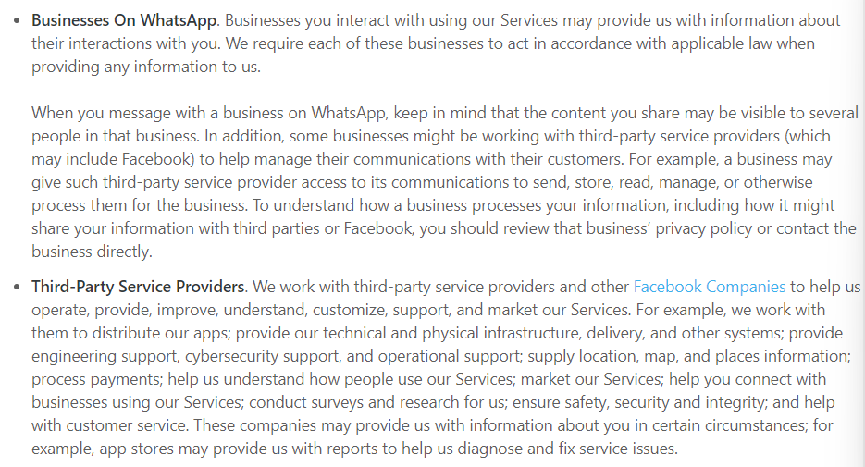

Appendix 1: Rules and regulations related to the third party information in the new privacy policy (WhatsApp, 2021).

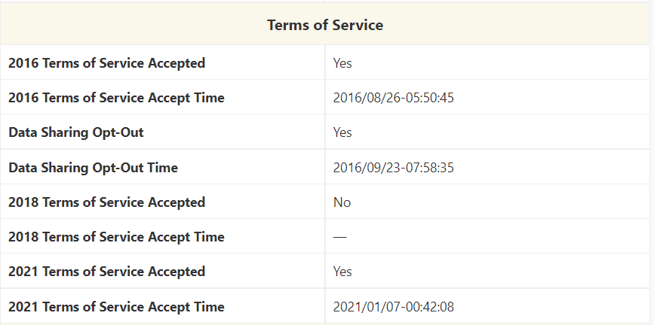

Appendix 2: Terms of services obtained by requesting account information from WhatsApp (T’nsam, 2021).

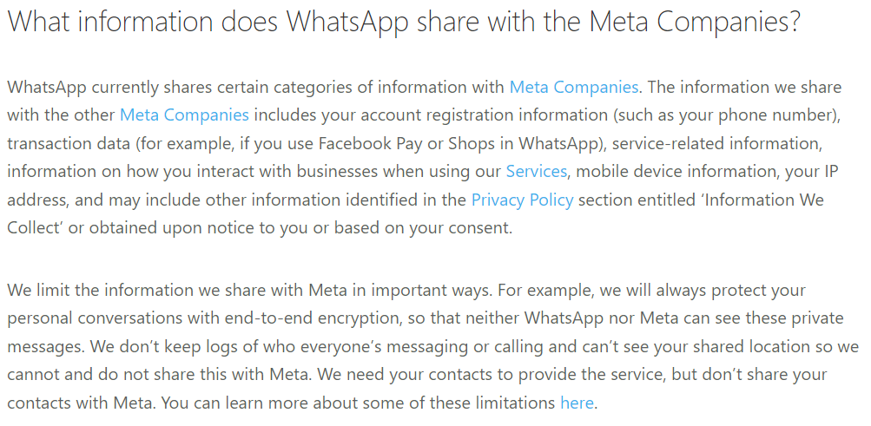

Appendix 3: Policy about information WhatsApp shares with the Meta companies (WhatsApp, 2021b).

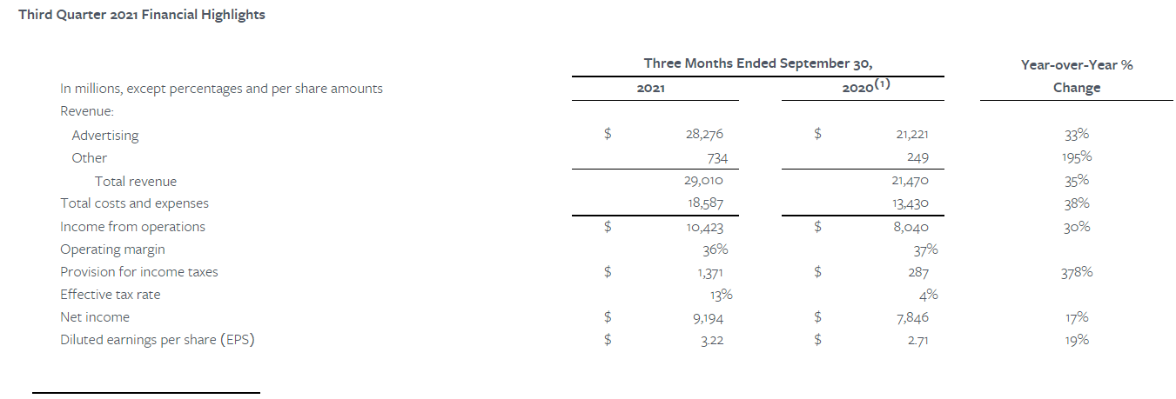

Appendix 4: Facebook Report Third Quarter 2021 Results (Facebook, 2021).

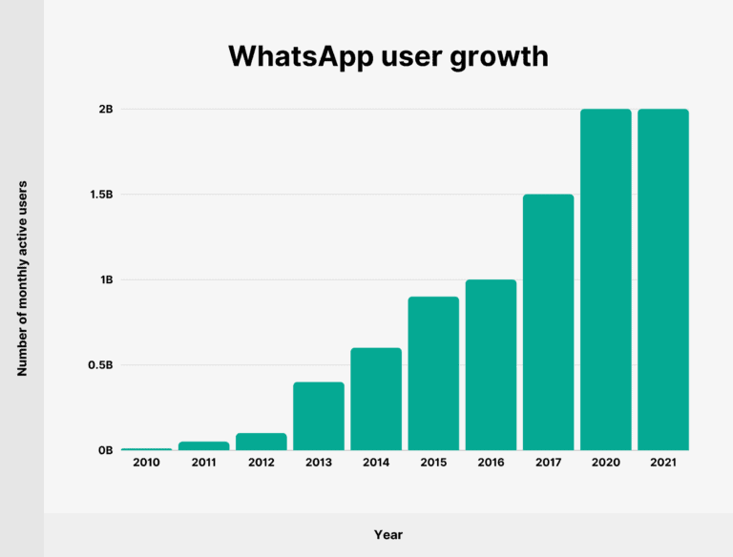

Appendix 5: WhatsApp user growth (Brian, 2021a).

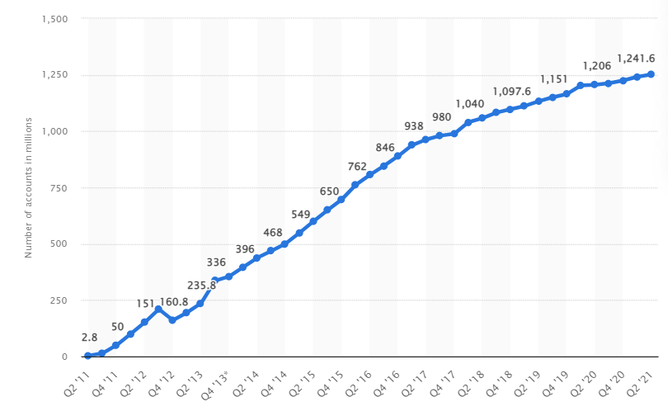

Appendix 6: Number of monthly active WeChat users from 2nd quarter 2011 to 2nd quarter 2021 (Thomala, 2021).

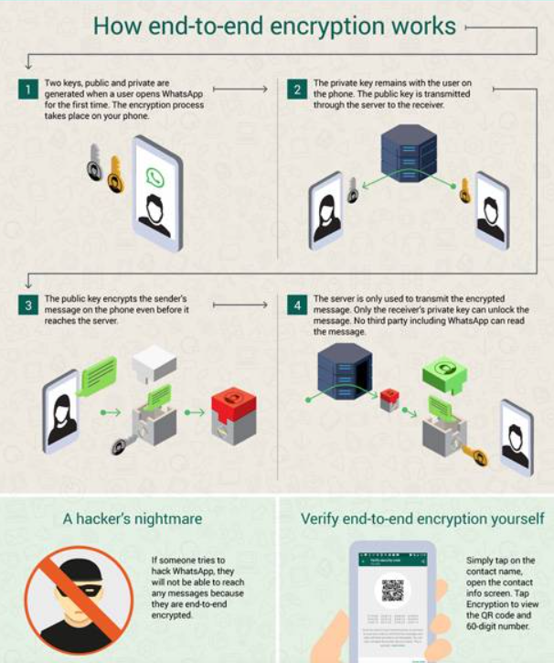

Appendix 7: Description of how the end-to-end encryption works (Business Today, 2019).

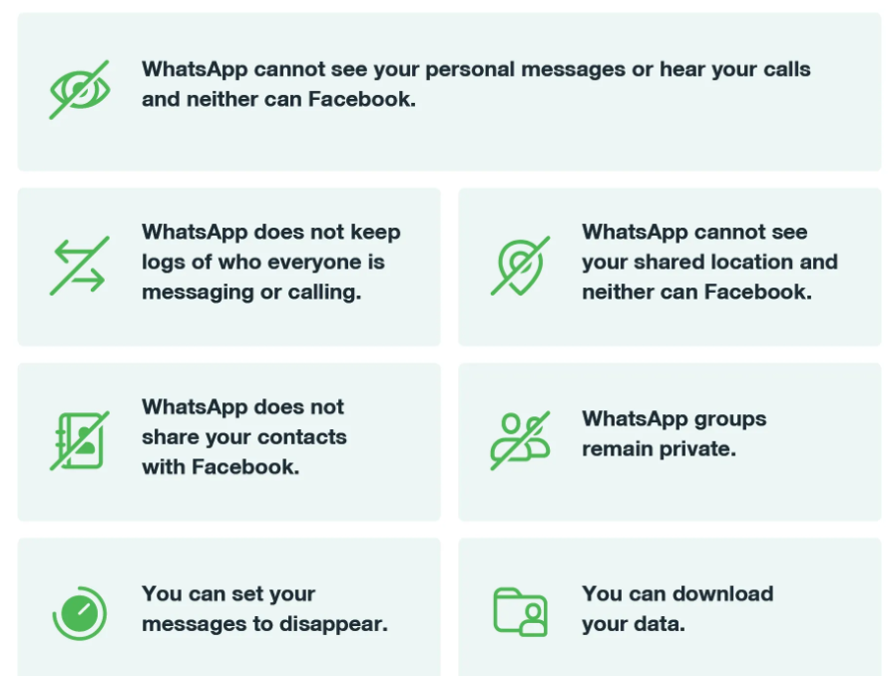

Appendix 8: WhatsApp privacy policy (WhatsApp Help Center, 2021a).

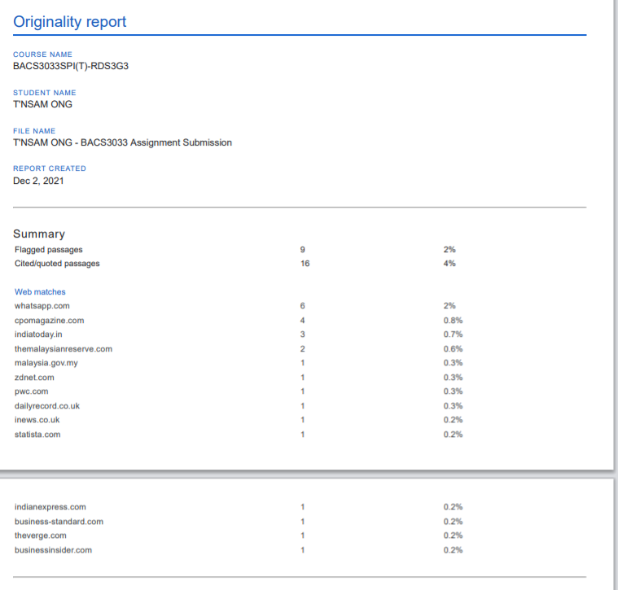

Appendix 9: Originality report.